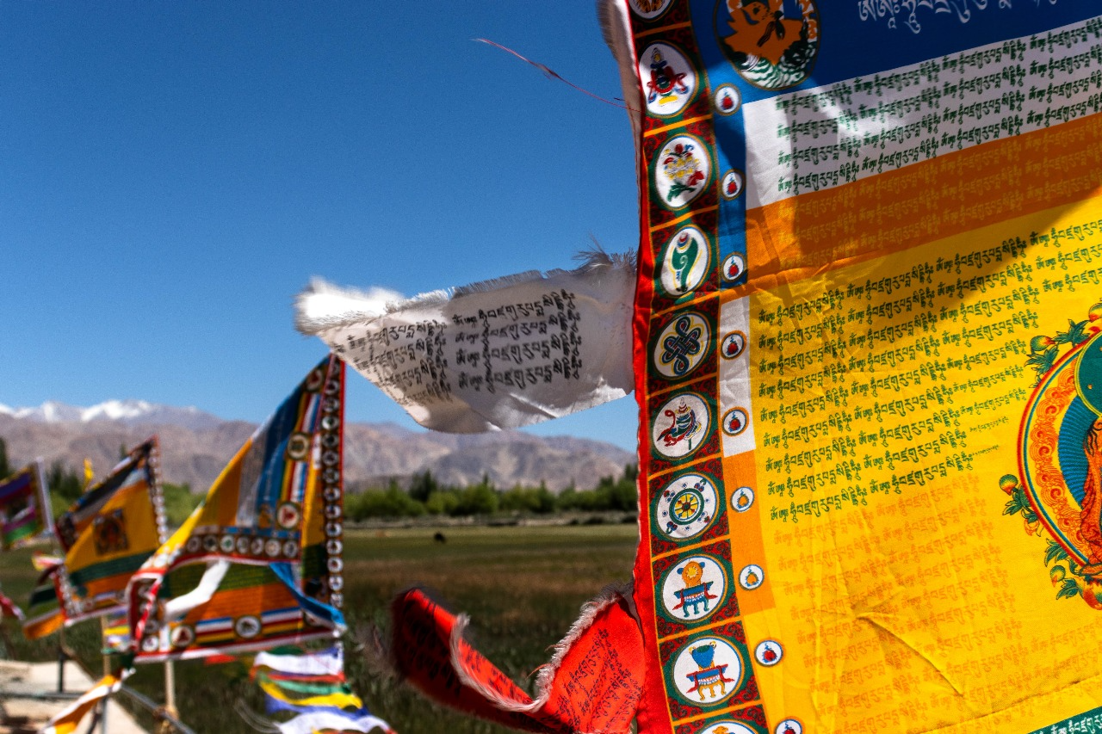
A Serendipitous Encounter with Peace
On our way back, we made a stop at the local market. My family, excited by the colors and crafts, dove into shopping, but I couldn’t bring myself to do the same. Markets didn’t hold my interest—I wanted to explore.
So, while they browsed, I wandered. Step by step, I drifted away from the chatter of vendors and the hum of negotiations, letting my feet guide me. After walking about half a kilometer, I stumbled upon something breathtaking.
There, against the backdrop of towering mountains and an open sky, were rows of vibrant prayer flags, their colors dancing wildly in the rushing wind. I stood still, mesmerized.
I’ve always been fascinated by the chants and hymns of Buddhism, their rhythmic cadence carrying a sense of ancient wisdom. The story of Buddha, as I had studied in history, was remarkable in itself, but in this moment, I wasn’t just reading about it—I was feeling it.
The prayer flags, inscribed with sacred mantras, fluttered like they were waving at me, calling me closer, whispering, Come, read us. Each ribbon carried prayers meant to be carried away by the wind, spreading blessings across the land.
I took a photo, capturing the magic, but as I lowered my camera, I realized something—this wasn’t just something to see; it was something to experience.
So, I sat down.
I let the moment wash over me, let the wind press against my skin, let my mind grow quiet. No thoughts, no rushing, no distractions. Just being.
For those few minutes, I wasn’t a traveler, a tourist, or even just an observer. I was simply there, part of something ancient, something peaceful, something beyond words.
And that moment, more than any photograph, is what I chose to carry with me.

